Extendable Desktop Search
Intro

Our project title is Extendable Desktop Search. It is a desktop application which will be used to retrieve any kind of data that is present in the system, data in the forms of files, music collection present on remove devices like cd, usb or hierarchical data sources like windows registry e.t.c. What makes difference b/w this and the traditional file searching applications is that with the growing size in the hard disc storage space it is inefficient and not practically feasible for retrieving the data the way user wanted and this also limits the ability to query the information in various parameters. (becoz traditional searching employs on demand sequential scan of entire hard disc after the user has given the query)

It addresses the basic problem of information retrieval (IR) faced by almost every user with reasonable data in his/her machine.
Before going what actual our project offers it’s better to have a look at the limitation of the currently available solutions on the market.

Windows search lacks in following features

- Cannot query the files based on their company name , product description e.t.c for example it can be used to answer a query like “files with the company name ‘microsoft’ “.

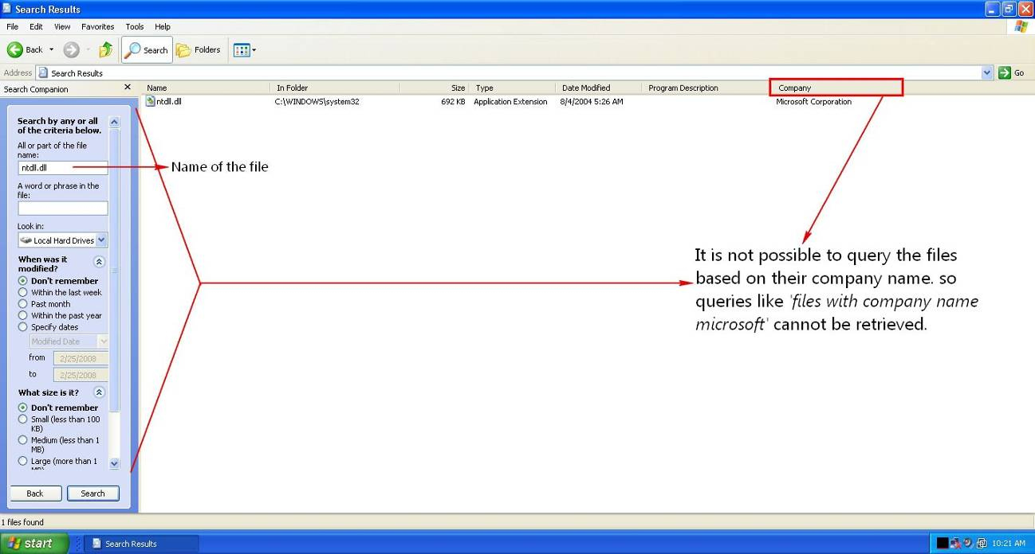

- Does not provide proper UI for query multimedia files based on their metadata attributes. Inconsistence UI
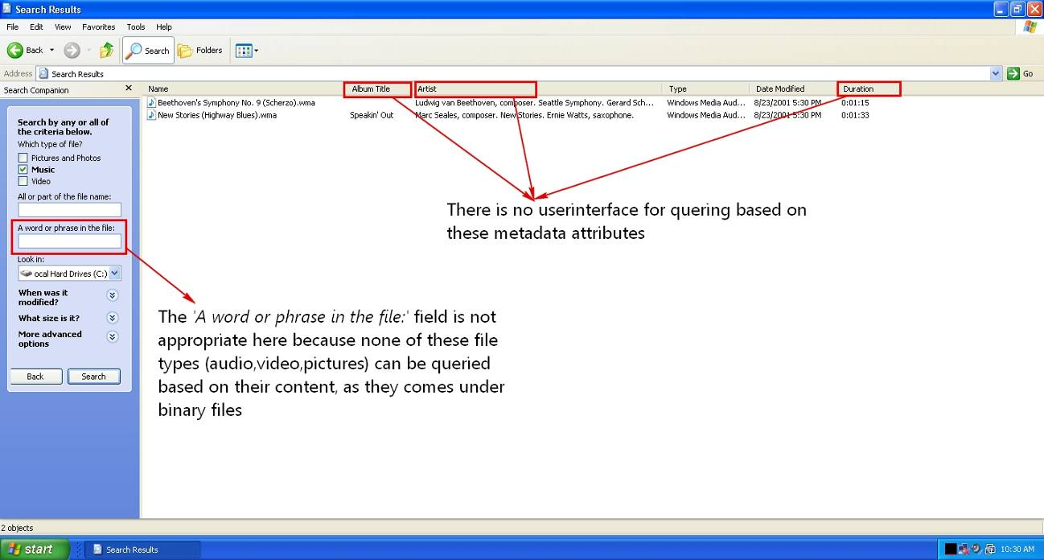

- Windows search cannot process commonly used compressed formats like rar,tar,bz2,gz formats
(it can handle only zip format)

- It has no option for extending its capabilities with 3rd party add-ons. --- Absence for extensibility mechanism.

Google Desktop Search:

- The following are the screen shots of Google desktop search. 1st picture lists all the wav files.
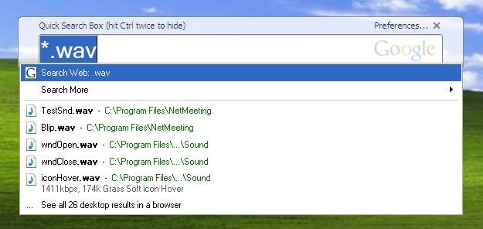

- But it cannot handle queries like “all wave files starting with letter ‘b’ “.
To our surprise when u pose such a query it results no files at all even though we have a file with name ‘blip.wav’

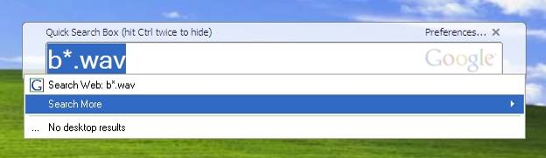

It lacks support for regular expression.

To alleviate this, our project indexes the contents of documents, metadata attributes of audio and video files.

As the application does not query the files in traditional manner (sequential file scanning) rather it depends on the indexed content. The results are obtained almost instantaneously.

It supports a well defined, easy to implement plug-in framework to helps 3rd parties to add their own file parsers to the application.

The operating environment for EDS

Hardware
- Processor: Intel 1.6GHz
- Memory: 256MB
- Hard Disc: 10MB

Software
- OS: Windows NT(2000,XP)
- Framework: .NET 2.0

Design and Implementation
We have chosen .NET because of 2 reasons
- .NET is cross language interoperable – which facilitates 3rd parties to write file parsers in any .NET aware languages (VB.NET,VC++.NET)

- .NET provides better integration features to windows operating system (which is not the case with other languages like JAVA) accessing windows registry. Adding to the startup of windows e.t.c creating background processes( for file scanning while indexing)

C# is chosen as the language of implementation because of its strong support for component oriented programming paradigms and versioning capabilities.

Software Modules
- Indexing Module
- Content Parsers Module
- File System Monitoring Module
- File System Crawler Module
- Query Builder Module
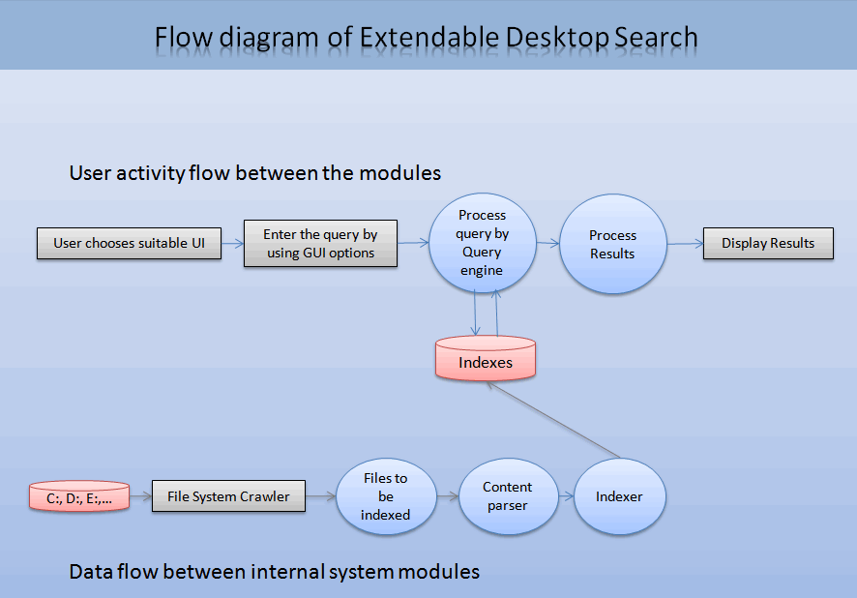

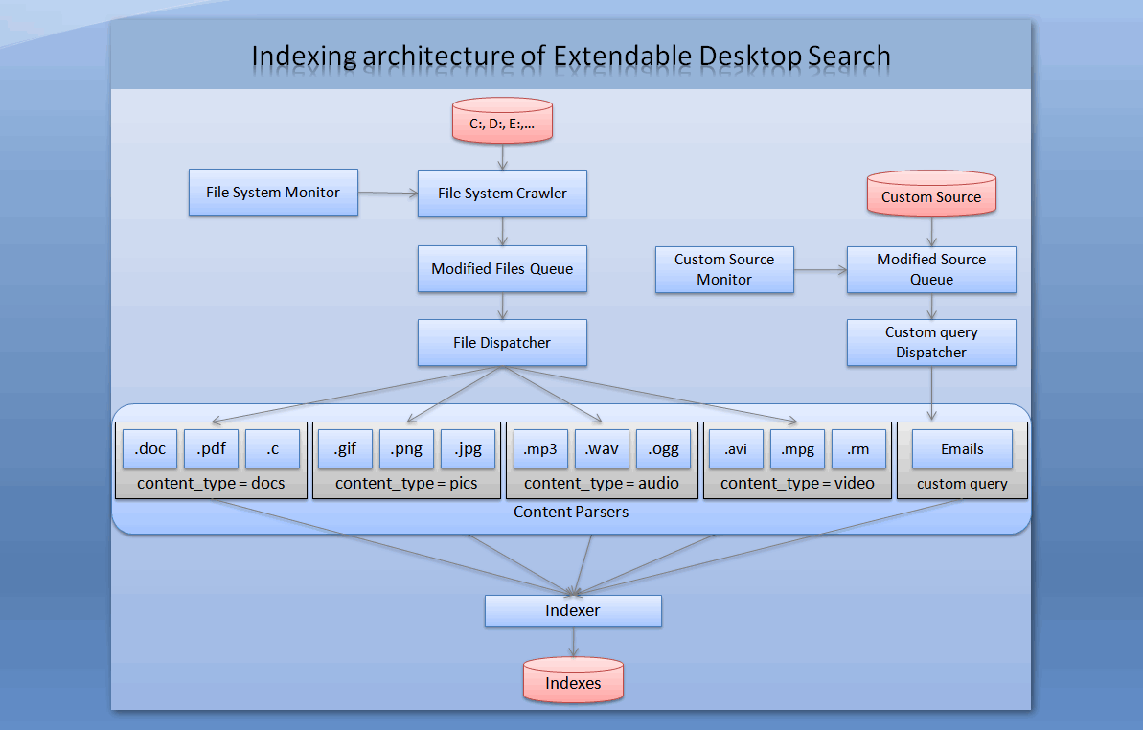
- Indexing Module: This is the core component responsible for indexing the contents of major document formats (.doc, .pdf), metadata attributes of audio and other binary file formats.

Indexing module will intelligently assign a ranking factor to the file being indexed, based on the number of times the file got updated/read.
The indexing module can only understand the data in textual format, as a result, extraction of textual information from documents and other binary files will be handled by Content Parsers module.
The textual information given to indexing modules will be in KEY, VALUE pair. For example if ‘content’ is the key then the document’s content is the value, if ‘author’ is the key then the file author name is the value.
The indexing module filters the unnecessary linguistic words (an, the, in etc) from being indexed, greatly reducing the size of indexes. This module uses Inverted Indexing scheme to organize the data.
- Content Parsers Module: This comprises of various parsers that can handle (parse) their respective file types.

The input to this module is a file (parser specific) and the output is textual content, which will be fed as an input to the indexer.
As an example, if input to this module is a doc file then the output will be a plain text extracted from the doc file, similarly if the input is an audio file then the output will be all metadata attributes like bit rate, composer etc
- File System Monitoring Module: It look after the file system changes that have occurred due to creation, deletion, updation of files by the user. It will also monitor the open files that are being used by the currently running processes in the system, as these files are more likely to be modified (a file opened in notepad has more chance of getting modified than the files not opened by any process).

- File System Crawler Module: It will scan the hard disc at regular intervals to collect the files that need to be indexed and maintains them in a queue. This module is designed to calculate the CPU’s idle time to schedule itself for the next scan. In this way the user at work will not be interrupted by the crawling activity.

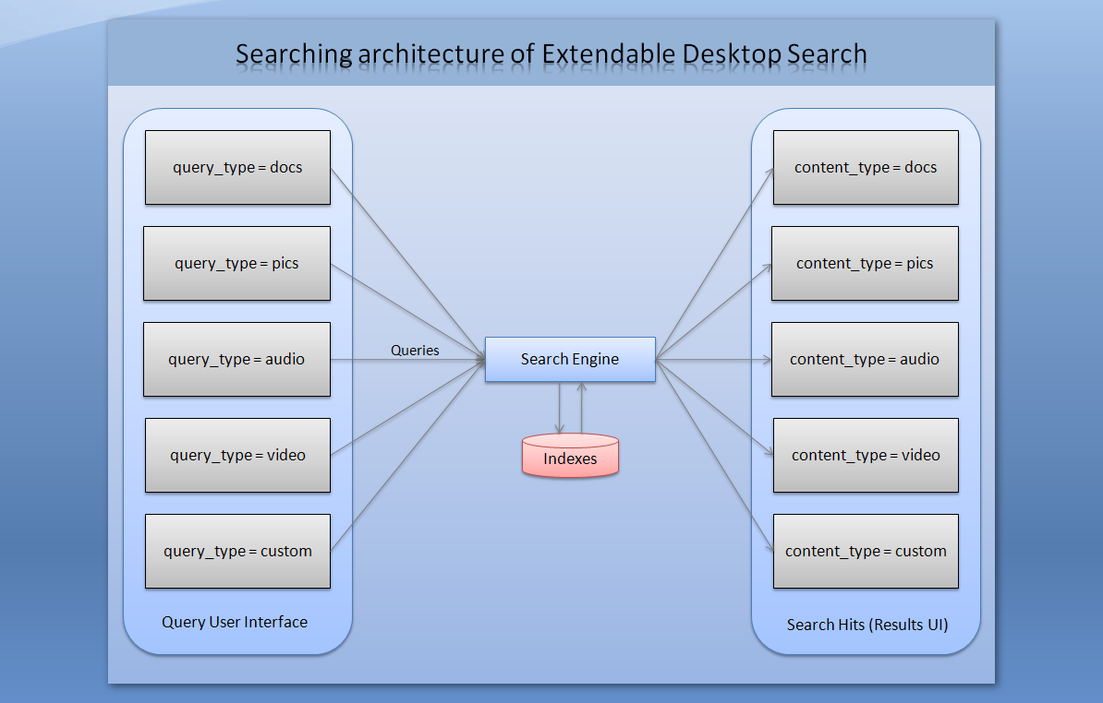

- Query Builder Module: This module is the information retrieval component of the software. The input to this module is a query, which will be given by the user by selecting various options in the GUI. The given query is analyzed by this module and fetches the results according to the ranking assigned from the indexes.

USER INTERFACE
Extendable desktop search provides user interface for following content types
- Documents
- Pictures
- Audio
- Video
- Registry

Documents

This interface provides the user for searching files based on following properties

- File Name
- Size
- Type
- Date
- Content
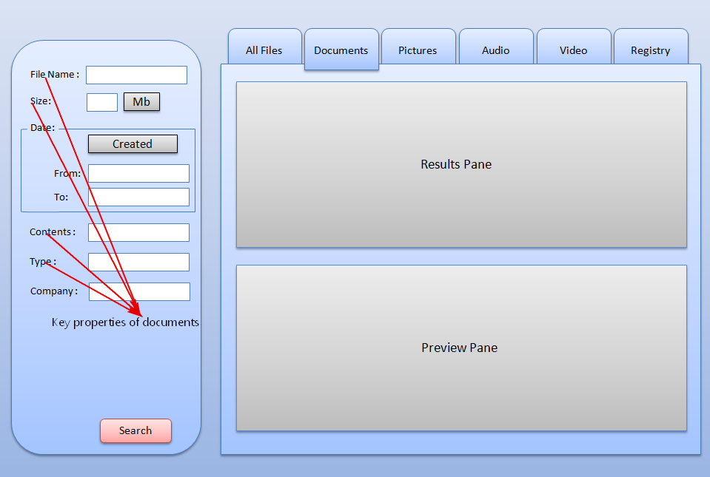

User has the choice of entering any of the details for the above properties. The important property of this interface is the Contents property, this field is responsible for querying the documents based on their contents.
The application is built with following popular content handler specific to documents.

- Microsoft Word
- Adobe Portable Document Format
- Web Documents (Html, Htm )
- Compressed Files(rar,zip,gzip,bz2)

Other unknown document formats cannot be queried based on their content property. Document formats that have no valid content handler will can only be queried on their basic properties like File Name, Date, Size etc

Pictures

This interface provides the user for searching image files based on following properties

- File Name
- Size
- Date
- Type
- Dimension
- Color Depth
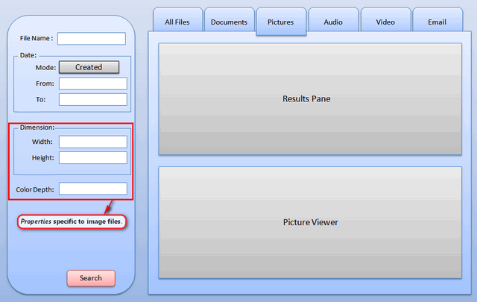

Coming to pictures all the basic properties (File name, Size, Date) remains same. The Extra properties that are specific to pictures are Dimension, Color Depth. Dimension field is responsible for querying the documents based on their Dimension (Height, Width).
Color Depth field is responsible for querying the documents based on their Color Depth Values (1, 8, 16, 24, 32, 48, 64).
The application can handle following image formats.

- Bitmap (bmp)
- Graphics Interchange Format(gif)
- Joint Photographic Experts Group Format(jpeg)
- Portable Network Graphics (png)
- Tag Image File Format (tiff)
- Exchangeable Image File(exif)

Other proprietary image formats like photoshop document (psd) can only be handled if the appropriate handler is present.

Audio and Video

This interface provides the user for searching audio files base on following properties

- File Name
- Size
- Date
- Duration
- Title
- Artist
- Album
- Genre

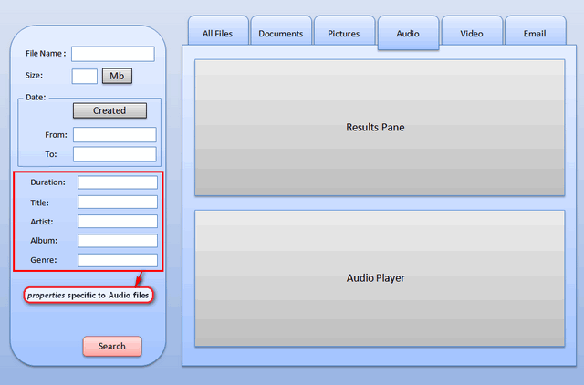

This interface gives the user full control in searching audio and video files based on various metadata properties.

The application can handle following audio and video formats.

- MPEG Layer-3 (mp3)
- Waveform audio (wav)
- Ogg Vorbis (ogg)
- Windows Media Audio (wma)
- Audio Video Interleave (avi)
- MPEG-4 (mp4)
- Windows Media Video (wmv)

Windows Registry
This is an example to show that our desktop search not only works with files but also with data that cannot be queried or accessed directly for manipulation. Windows registry stores settings and options for the operating system. It contains information and settings for all the hardware, operating system software, most non-operating system software, users, preferences of the PC, etc
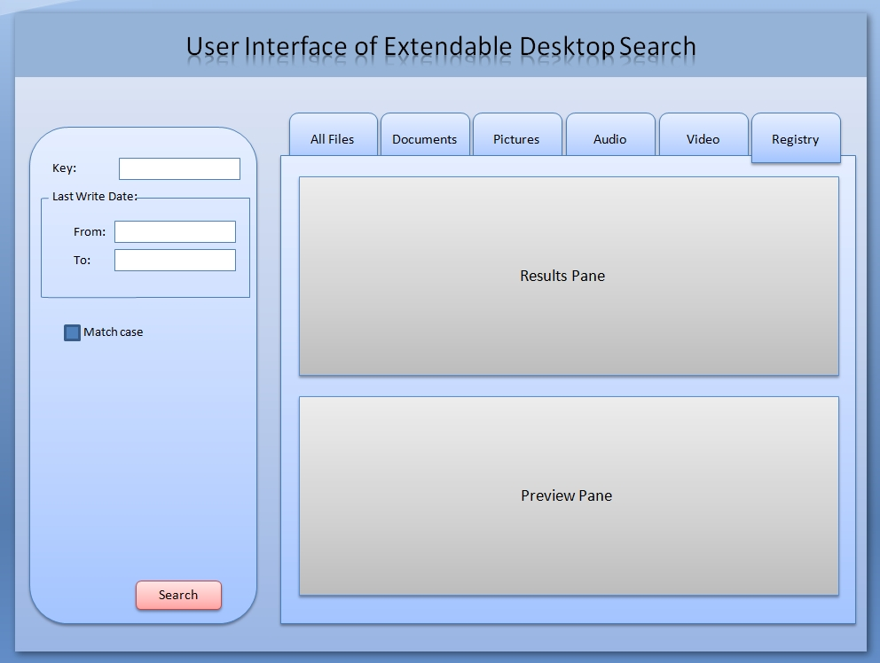

System Features
- Full Regular expression support for querying files by their names
This feature requires the implementation of regular expressions to support queries like “files ending with txt extension”, “files starting with ‘a’ and of length 6 characters” etc.
This feature handles the invalid inputs given by the user and tries to anticipate the relevant query. For example if the user has typed “kernl32.dll” as the file name, it automatically detects the misspelled file name and suggests the user with the correct one as “Kernel32.dll”.
- Query information by file content
This feature provides an extra level of information retrieval by allowing
user to query for the desired file based on its contents rather than its
name.
The contents of the files vary with each file type, for example the file format of Microsoft Word is completely different from that of Adobe’s Pdf (portable document format).
This particular feature necessitates the use of content parsers. The content parser module is used to handle all major file types. The input to this module is a file (parser specific) and the output is textual content, which will be fed as an input to the indexer.
- Supports Plug-in framework for parsing new file types
This helps 3rd parties to extend the features of the application. To be able to accept an extension as a plug-in it should implement the interface IEDSParser. Every extension should be able the parse the input content and return the results back to the caller in a list containing KEY, VALUE pairs.
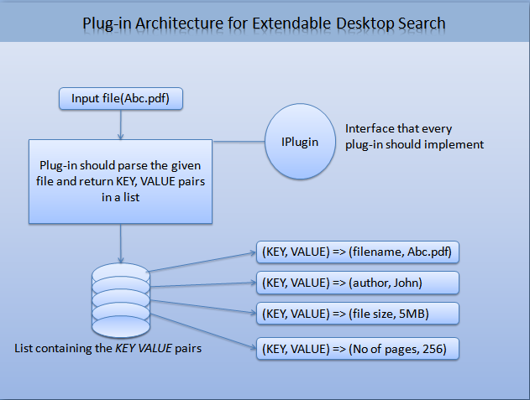

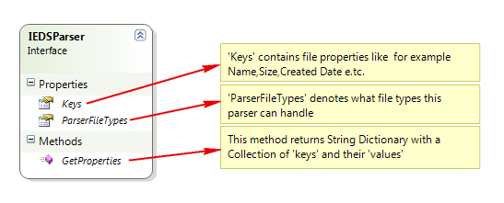

Indexing of remote system’s data
It helps lab administrators to index the contents of all the systems without
actually installing it on each client and helps them in searching the contents of the remote client from his machine.

IMPLEMENTATION

File system monitor
The file system monitor interfaces with File System Crawler component and Modified File Queue data structure.
The following tasks are performed by File System Monitor
- It contains a list of monitors whose activities should be analyzed .These sources are stored in an dictionary
- Each FileSystemWatcher monitors the file system activities and captures file delete, create, change and rename events.
- Checks whether we have sufficient permissions to read the event generated source (deleted, updated file) or not.
- Finally the path to the event and the operation type is stored in a create, rename, delete lists
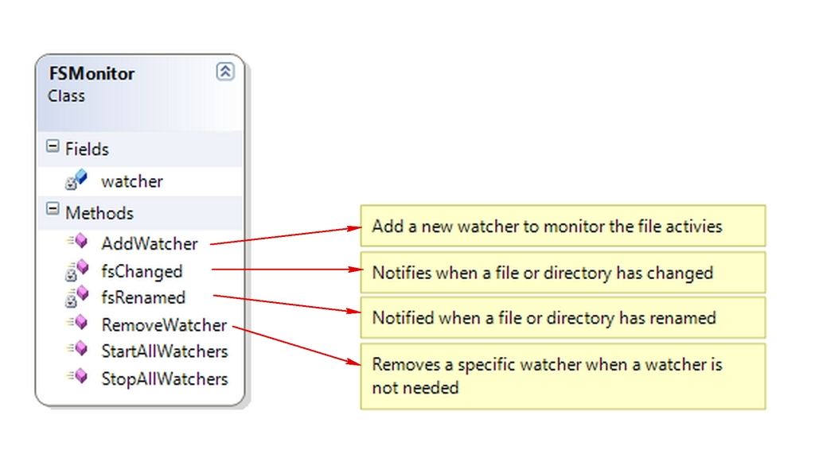

File Dispatcher
This component is responsible for enumerating all the built-in, 3rd party installed file parsers.
It takes the file to be indexed and invoke the appropriate handler for parsing it
This component is encapsulate in FileDispacther class
This class is responsible for invoking appropriate parser based on the file type. After invoking the parser the KEY VALUE pair properties will be submitted to the indexer
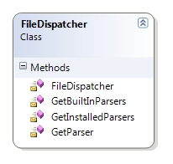
File Dispatcher Class
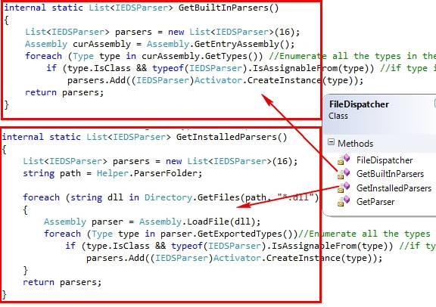

The above two methods enumerated the file parsers present in the system

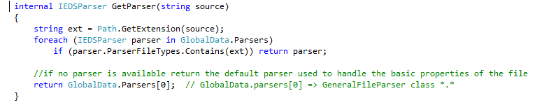

INDEXER

Indexer is the component which will convert the given data into a format (inverted indexes) which facilitate fast retrieval of the information.
The logical view of the indexes is as shown below
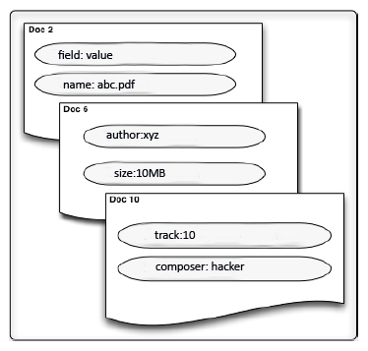
The above figure contains 3 documents with the mentioned fields and their values. We can manipulate these indexes only in terms of documents i.e., we can only add new documents or delete existing documents. This object oriented view of indexes makes it easy to organize and consume for other components in the application. The indexes also contain one important feature responsible for giving rank to each document, it is called boosting factor. By default every document is indexed with a boosting factor of .5(neither important doc nor unimportant doc), by setting the boosting factor of a document below .5 implies the document is less important than usual and setting it to above .5 implies the document is more important. This attribute to every document is very helpful in sorting the results in the order of their importance. The boosting factor varies from 0 to 1 with the default being .5

Content Parsers
To keep the implementation of the indexer simple, the indexer can only digest plain text in the form of key value pairs.
By not being specific to a particular file type, makes indexing engine more generalized in handling any file type provided there is a parser which can convert the input file into plain text.
Content parsers deal with
<…………..Yet to be completed………>

